A M.Sc. Research Proposal
NAME: OYELUDE, Balikis Olawumi
Machine Learning application to leak detection in Oil, water and gas pipelines using open source software
- INTRODUCTION
Pipelines remains the most important and efficient means of transporting products vital to the sustenance of national economy in the world such as water, oil and gas (Dawotola et al.,2009). Given the increasing demand and dependence on oil and gas which are non-renewable as a major source of energy, it is important not only to ensure continuous discovery of new hydrocarbon but also ensure that the produced quantities are efficiently utilised by ensuring their safe transportation and distribution from their point of production to point of consumption which could be a lots of kilometres apart.
Water is also another valuable resources which can maintain a substantive modern life and economic growth and transmit with pipelines. Leaks are known to be among the major threat to pipeline transport system which could be due to physical damage, deterioration, installation defects and aging. Oil, gas, and water leakages causes the potential danger to public health and also leads to wastage of resources. In order to minimize the risk associated with oil, gas and water leakages, identifying and locating the leaks in pipeline system are crucial. In leakage control process, leak detection remain the critical step of overall leakage process.
To address this issue, this work would explore data driven machine learning for leak detection of oil, water and gas. The performance of data driven approach is a function of availability of historical data. For water, simulated data with industry certified hydraulic model EPANET would be used to generate data. A supervised machine learning and unsupervised machine learning algorithm would be used to detect leak in water, oil and gas respectively.
- PROBLEM STATEMENT AND SIGNIFICANCE OF STUDY
Many researchers have presented machine learning model for water distribution network, oil and gas pipelines and quite a number of them did not account for natural events such as landslides, flood and erosion in general. It is therefore important that the condition of pipelines is adequately monitored. The existing machine learning algorithms for leak detection are ANN, Bayesian probabilistic analysis, Naives bayes, decision tree, random forest, support vector machine and k-nearest neighbour. Each of these features have both advantages and limitations. Caruna and Niculescu (2006) showed that artificial neural network (ANN) is among the top 5 best algorithm during its application on eleven binary classification problems using eight performance metrics.
In this study, to address the challenge posed by water distribution network and oil/gas pipelines, this work would use a technique based on software, combining a simulator such as EPANET and OLGA for water supply network and oil/gas respectively. An interesting part of the study would be the combination of data driven simulation software to generate data and at least two technique of machine learning such as artificial neural network (ANN) and Autoencoder neural network to issue leak or anomaly detection (Chandola.,2019; Banerjee and Kumar., 2009). This combination would allow the modelling of leak and non-leak conditions of the pipelines to detect any possible leak. In addition to the technical choice, the use of open license, open source which allow a specific customization to the reality of pipelines and a great reduction in costs is an important part of the study.
- OBJECTIVES
  - Aim of study
The main aim of this research is to design a condition and prediction model for leak monitoring of typical water distribution, oil, gas network.
3.2. Outlines of the objectives
1. To design a condition and prediction model for leak detection for oil, gas and water on a technique based on open source software.
2. To determine the role natural event such as flood, erosion plays on leak detection in water distribution network.
3. To compare the efficiency and accuracy of a supervised learning model such as ANN and unsupervised learning model such as Auto-encoder neural network.
4. To design the prediction model for monitoring of leak detection in University of Lagos, Nigeria water distribution network.
4.0 METHODOLOGY
Artificial Neural Network (ANN) is a supervised machine learning (ML) model. The architecture of ANN includes interconnected neurons in the input layers, hidden layers, and output layers. The number of layers and the number of neurons in each layer determine its overall performance. Increasing the number of neurons and hidden layers can improve the ability of ANN model to describe complex nonlinear relationships. It, however, also increase the computational demand and potentially lead to overfitting. An optimal ANN architecture for this study is determined by an optimization process, which leads to an ANN model with one input layer, three hidden layers, and one output layer, as in figure 1

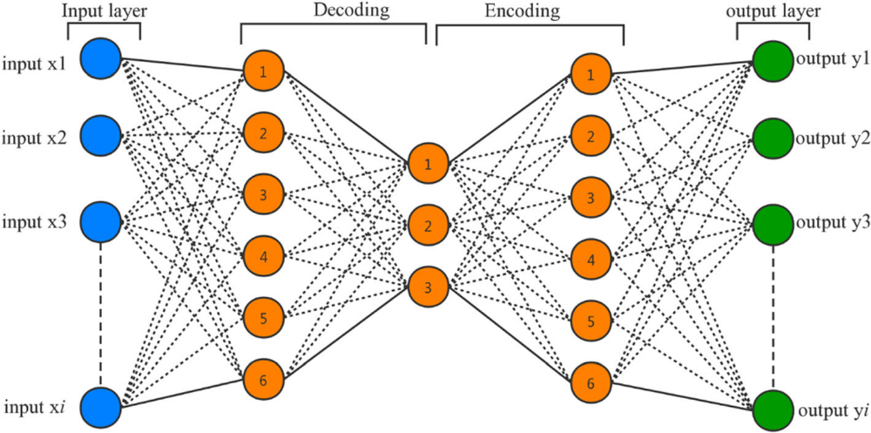

Figure 1. Schematic of ANN architecture

The input layer consists of I neurons, which are corresponding to the number of input features. The hidden layers provide the capability to model the complex non-linear relationships which are fine-tuned with the training data. The output layer consists of one neuron which is used to classify the output as leaking or not leaking condition. The hidden layers include fully connected neurons, the output of each neuron is written as follows.
Autoencoder neural network is an unsupervised machine learning model. It is based on a special type of neural network that is trained to reconstruct its input, so the output
(y1,y2,y3,…,yn) would contain the same information as its input (x1,x2,x3,…, xn). To reduce the reconstruction error, the network is forced to learn the hidden patterns between the input data. An innovative strategy is proposed in this study to detect the leaking situation by autoencoder neural network based on its reconstruction error.
Then the model will reconstruct the compressed data into its original space, which is called the decoding process. By reducing the error between output and input, the weights and bias of the neurons in the neural network are adjusted to learn the relationship among the input data. For a model trained by dataset of only non-leak condition, a large reconstruction error occurs it is inputted with data of leaking condition because the relationship described by the trained AE neural network is not valid under such condition. By setting a threshold in the construction error, the AE model can classify if a set of data corresponds to a leaking situation or a non-leaking situation.

Figure 2.0. Schematic of Auto-encoder architecture.

4.1 EPANET MODEL FOR WATER DISTRIBUTION NETWORK
A hydraulic model is commonly used to compute the hydraulic parameters such as water pressure or water head and flow rate for the design of a water distribution network. The governing hydraulic equations describe the conservation of mass and conservation of energy considering the topological characteristics of a water pipe network. The hydraulic model allows to account for the water usage behaviours (described as water demand fluctuations at the service nodes) and events such as leakages on the network performance. While hydraulic model is regarded as sufficiently accurate for water network planning purpose.

REFERENCES
A. Khodayari-Rostamabad, J. P. Reilly, N. K. Nikolova, J. R. Hare, and
S. Pasha, “Machine learning techniques for the analysis of magnetic
flux leakage images in pipeline inspection,” IEEE Transactions on
magnetics, vol. 45, no. 8, pp. 3073–3084, 2009.
Network System by using Epanet,” Manager’s Journal on Civil Engineering, vol. 6, no. 2, p. 42, 2016.
Dawotola, A. W., Gelder, P. H. A. J. M. V. & Vrijling, J. K. 2010. Multi Criteria Decision Analysis framework for risk management of oil and gas pipelines. RELIABILITY, Risk and Safety. London: Taylor & Francis Group, PP. 307-314.
J. Doorhy, “Real-time pipeline leak detection and location using volume balancing,” Pipeline Gas J, vol. 238, no. 2, pp. 65–67, 2011.
S. Rashid, U. Akram, S. Qaisar, S. A. Khan, and E. Felemban, “Wireless sensor network for distributed event detection based on machine learning,” in 2014 IEEE International Conference on Internet of Things (iThings), and IEEE Green Computing and Communications (GreenCom) and IEEE Cyber, Physical and Social Computing (CPSCom),
pp. 540–545, IEEE, 2014.

